K . Ashritha
192225061
18\12\2025

11. Scenario : You are a data scientist working for a company that sells products online. You have been tasked with creating a simple plot to show the sales of a product over time.
Question:
1. Write code to create a simple line plot in Python using Matplotlib to predict sales happened in a month?
2. Write code to create a scatter plot in Python using Matplotlib to predict sales happened in a month?
3. Develop a Python program to create a bar plot of the monthly sales data.
CODE:
import pandas as pd
import matplotlib.pyplot as plt
df = pd.read_csv("/content/monthly_sales_data (1).csv")
plt.plot(df["Month"], df["Sales"], marker='o')
plt.xlabel("Month")
plt.ylabel("Sales")
plt.title("Monthly Sales Trend")
plt.xticks(rotation=45)
plt.show()
plt.scatter(df["Month"], df["Sales"])
plt.xlabel("Month")
plt.ylabel("Sales")
plt.title("Scatter Plot of Monthly Sales")
plt.grid(True)
plt.xticks(rotation=45)
plt.show()
plt.bar(df["Month"], df["Sales"])
plt.xlabel("Month")
plt.ylabel("Sales")
plt.title("Bar Plot of Monthly Sales")
plt.xticks(rotation=45)
plt.show()

OUTOUT:
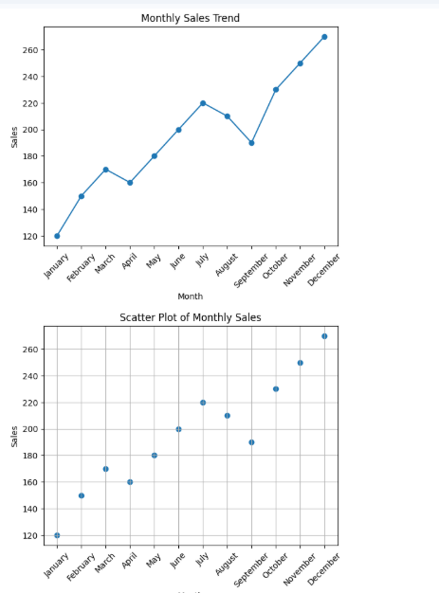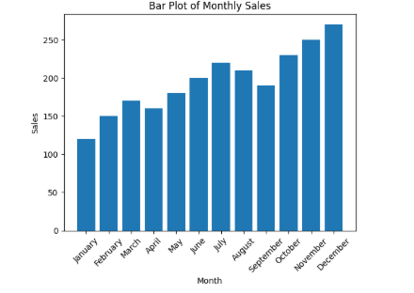

12. Scenario: You are working on a data analysis project that involves analyzing the monthly temperature and rainfall data for a city. You have a dataset containing the monthly temperature and rainfall values for each month of a year. Your task is to develop a Python program that generates line plots and scatter plots to visualize the temperature and rainfall data.
Question:
1. Develop a Python program to create a line plot of the monthly temperature data.
2: Develop a Python program to create a scatter plot of the monthly rainfall data.

CODE:
import pandas as pd
import matplotlib.pyplot as plt
df = pd.read_csv("temperature_rainfall_dataset.csv")
plt.plot(df['Month'], df['Average_Temperature_C'])
plt.xlabel('Month')
plt.ylabel('Temperature (°C)')
plt.title('Monthly Temperature')
plt.xticks(rotation=45)
plt.grid(True)
plt.show()
plt.scatter(df['Month'], df['Rainfall_mm'], color='b')
plt.xlabel('Month')
plt.ylabel('Rainfall (mm)')
plt.title('Monthly Rainfall')
plt.xticks(rotation=45)
plt.grid(True)
plt.show()

OUTPUT:
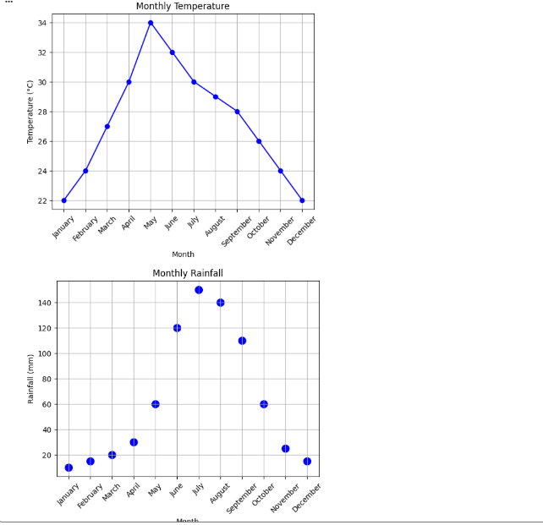

13. Scenario: You are working on a text analysis project and need to determine the frequency distribution of words in a given text document. You have a text document named "sample_text.txt" containing a paragraph of text. Your task is to develop a Python program that reads the text document, processes the text, and generates a frequency distribution of the words. Question: How would you develop a Python program to calculate the frequency distribution of words in a text document?
CODE:
import pandas as pd
from collections import Counter
import re
df = pd.read_csv("/content/sample_text.csv")
text_column = df.columns[-1]
text = " ".join(df[text_column].astype(str)).lower()
text = re.sub(r'[^a-z\s]', '', text)
words = text.split()
freq = Counter(words)
print(freq)

OUTPUT:
Counter({'data': 5, 'science': 3, 'and': 2, 'analysis': 1, 'is': 1, 'a': 1, 'core': 1, 'part': 1, 'of': 1, 'work': 1, 'together': 1, 'to': 1, 'generate': 1, 'insights': 1, 'big': 1, 'machine': 1, 'learning': 1, 'are': 1, 'important': 1, 'helps': 1, 'in': 1, 'decision': 1, 'making': 1})

14. Scenario: You are a data analyst working for a company that sells products online. You have been tasked with analyzing the sales data for the past month. The data is stored in a Pandas data frame.
Question: Develop a code in python to find the frequency distribution of the ages of the customers who have made a purchase in the past month.
CODE:
import pandas as pd
df = pd.read_excel("/content/age.csv.xlsx")
age_counts = df['Age'].value_counts().sort_index()
print("Frequency distribution of customer ages:")
print(age_counts)

OUTPUT:
Frequency distribution of customer ages:
Age
20 1
30 2
40 2
50 1
60 2
70 2
80 2
90 2
100 2
300 1
350 1
400 1
Name: count, dtype: int64

15. Scenario: You are a data analyst working for a social media platform. As part of your analysis, you have a dataset containing user interaction data, including the number of likes received by each post. Your task is to develop a Python program that calculates the frequency distribution of likes among the posts.
Question: Develop a Python program to calculate the frequency distribution of likes among the posts?

CODE:
import pandas as pd
df = pd.read_csv("/content/drive/MyDrive/post_likes.csv")
print(df["Likes"].value_counts())

OUTPUT:
Likes
10 2
20 2
15 2
30 2
25 2
40 2
50 2
60 2
35 1
45 1
70 1

